**Note**: This special guidance is only applicable to Commercial and Industrial Partners completing Section 3A of the *Partner of the Year – Energy Management* and Section 2A of the *Partner of the Year – Sustained Excellence Energy Management* applications. Separate instructions for Industrial Partners are included in those applications.

The *Demonstration of Energy Savings* section of the above applications is intended to assess actual, quantified energy performance improvements achieved by your organization during the past year, and requires applicants to provide a Partner of the Year (POY) report from ENERGY STAR Portfolio Manager documenting these improvements. This guidance document provides directions for generating the POY report which EPA will use in conjunction with other information requested in this section to assess the following:

* Reduction in energy consumption, energy use intensity, and greenhouse gas emissions achieved across the portfolio during the past year,
* Number of buildings that have earned the ENERGY STAR (if applicable),
* General movement toward improved energy performance, with context provided to explain performance results, if needed, and,
* Extent of portfolio-wide benchmarking, with context provided to explain why any buildings or building data cannot be included in portfolio-wide reporting (e.g., new building acquisitions, less than 24 months of data available, etc.).

**We recognize that 2020 presented many challenges for managing energy use in buildings and documenting results due to COVID-19, and we will consider these challenges in our review of all applications.**

**Directions for Generating a Partner of the Year (POY) Report**

1. Go to <https://www.energystar.gov/portfoliomanager> to log in to ENERGY STAR Portfolio Manager.
2. Log in to the ENERGY STAR Portfolio Manager account that contains all of the buildings and benchmarking data for your organization. You must submit building data for your organization’s entire portfolio. If you cannot provide benchmarking data for certain buildings, or the buildings are not reflected in the account, be sure to address this in Section 2 of the application.
3. Click on the “Reporting” tab.
4. Identify the “Partner of the Year Report” in the list of reports at the bottom of the page. A screenshot of the “Reporting” tab and the list of reports available is provided below.

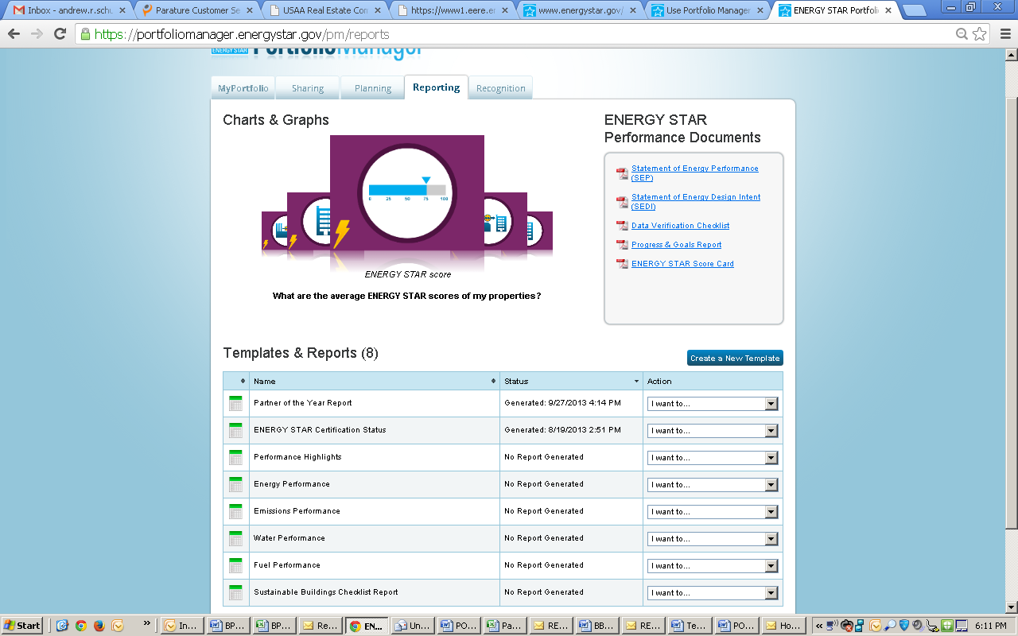

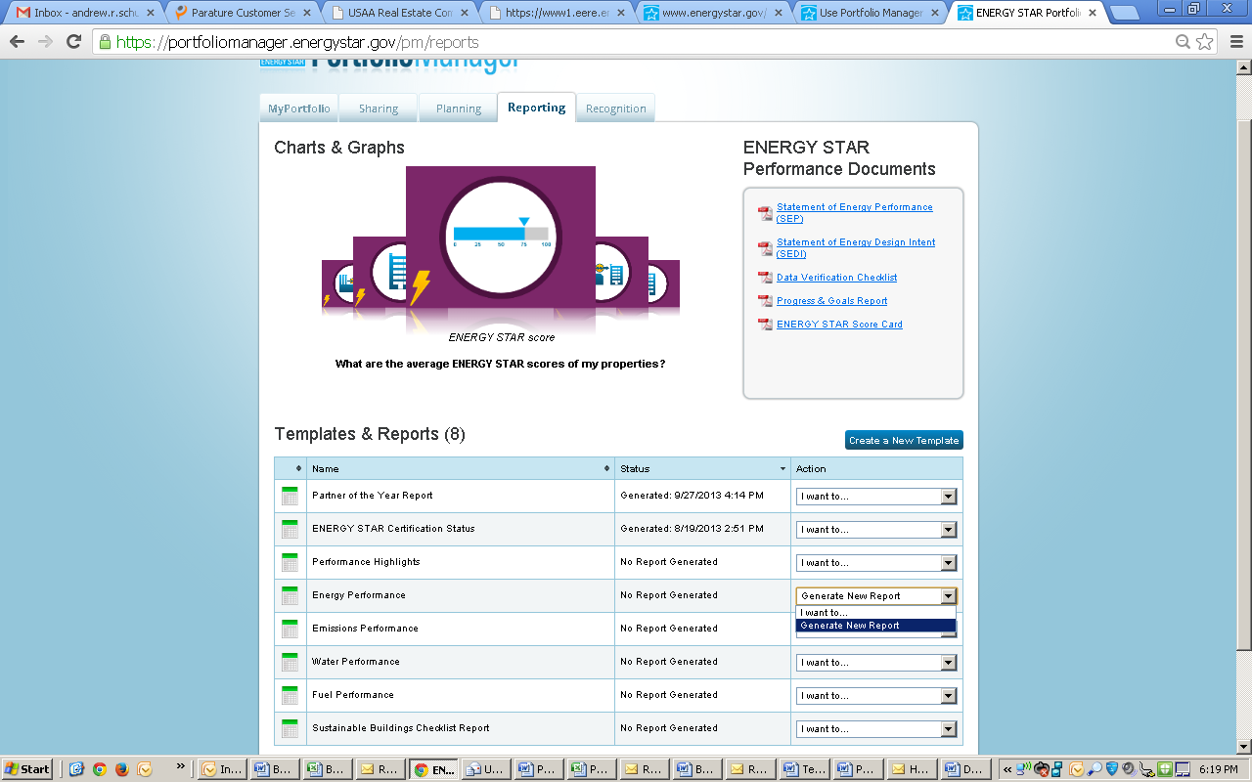



1. From the drop-down box in the “Action” column next to the report name, select “Generate New Report.” You will then be taken to a screen titled “Create Partner of the Year Report,” as illustrated below.

Step 6. In the “Create Partner of the Year Report” screen, you must choose a timeframe for the report.


1. In the “Create Partner of the Year Report” screen, you must choose a timeframe for the report.  
     
   To choose a timeframe, you must select **“Compare Two Years”** from the drop-down menu, as illustrated in the screenshot above. The second period must be August 2020 or later, and should be the month for which you have complete energy data for the greatest number of buildings in your portfolio. The first period should be the same month one year prior. For example, the screenshot above will generate a report comparing August 2019 to August 2020.
2. In the “Create Partner of the Year Report” screen, you must also select properties to include in the report.   
     
   You must choose **“All Properties”** from the drop-down menu, unless you have test or duplicate buildings in your account. In this case, select “Multiple Properties” from the drop-down and select all non-test or duplicate buildings to submit.

Please ensure that all non-test or duplicate benchmarked properties appear in the report, even if you do not have 24 months of data for all properties in your portfolio. ENERGY STAR asks you to do this because it is important to demonstrate the extent to which you are benchmarking the properties in your portfolio.

This screen also provides a list of metrics that are included in the report, provided under “Review Included Metrics.” You cannot change this selection of metrics.

1. Click “Generate Spreadsheet” to generate the report. You will now be returned to the main page of the “Reporting” tab.
2. In the list of “Templates and Reports” on the “Reporting” tab, you will see that your report has been generated, as illustrated in the screenshot below. In the “Action” column of the “Partner of the Year Report” row, use the drop-down menu to select “Download Current Report in Excel.”

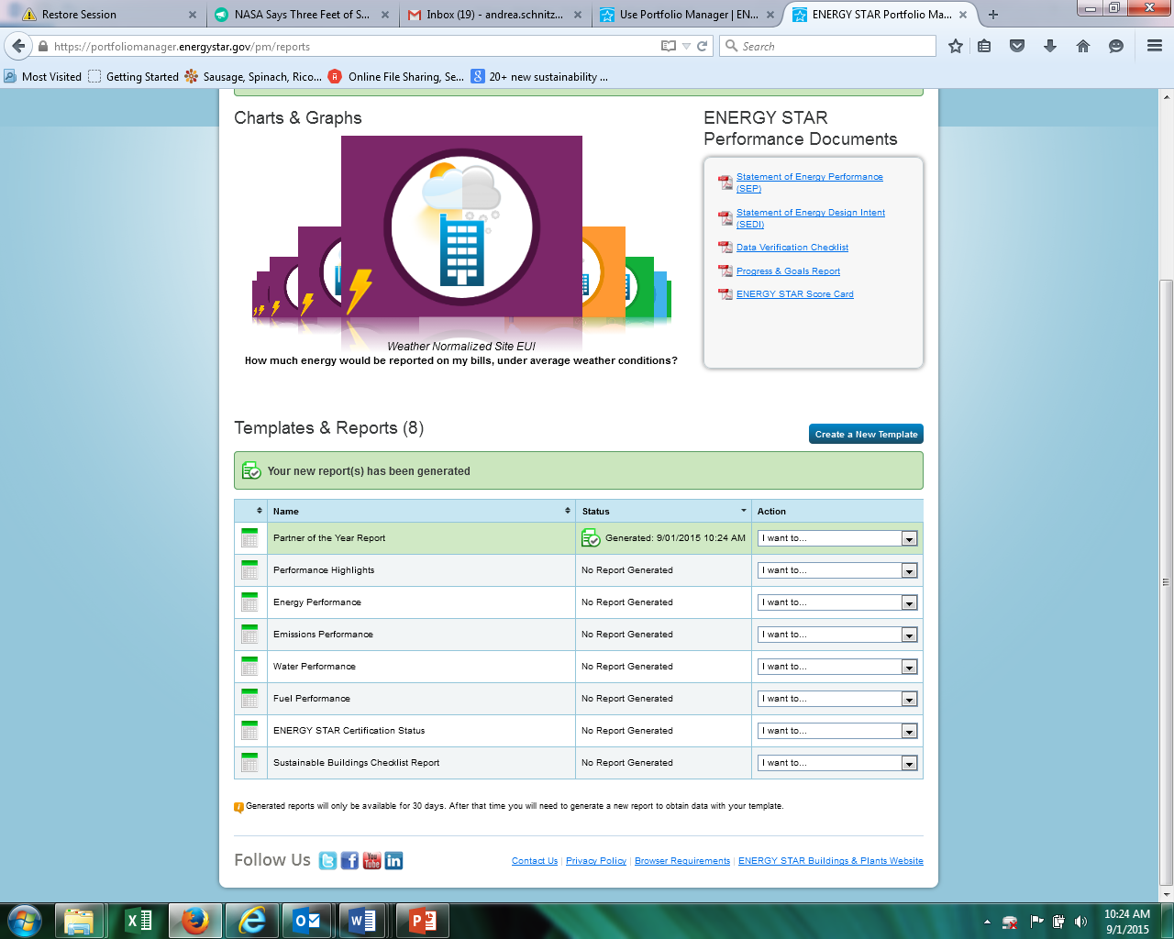

Open the Excel document that is generated to view your data. When you do, you will see three tabs.

* Tab 1 “Summary” contains **the table** **you must paste into Section 3A of your Partner of the Year Application**, and provide a discussion of the figures.
* Tab 2 “Information and Metrics” contains two rows for each of the buildings in your portfolio: one row contains data corresponding to the August 2020 (or later) period that you have selected, and the other line contains data corresponding to the comparison period selected, which should be 12 months prior.
* Tab 3 “Comparisons” contains one row for each building. The tab provides the calculated difference between the two time periods reported on the “Information and Metrics” tab for each metric.

With the information provided in this report, you can describe the energy consumption characteristics of your portfolio to demonstrate improvement, or give context for instances where little or no improvement is observed.

1. If you want to re-generate your report (if you’ve updated any energy data or Use Details (square foot, etc.)), you can do so by choosing “Generate New Report” from the “Action” drop-down menu illustrated under Step 9. If you want to change the properties selected or the comparison time periods, from the Action menu, “Select Properties and Timeframes.”

ENERGY STAR® is the government-backed symbol for energy efficiency, providing simple, credible, and unbiased information that consumers and businesses rely on to make well-informed decisions.