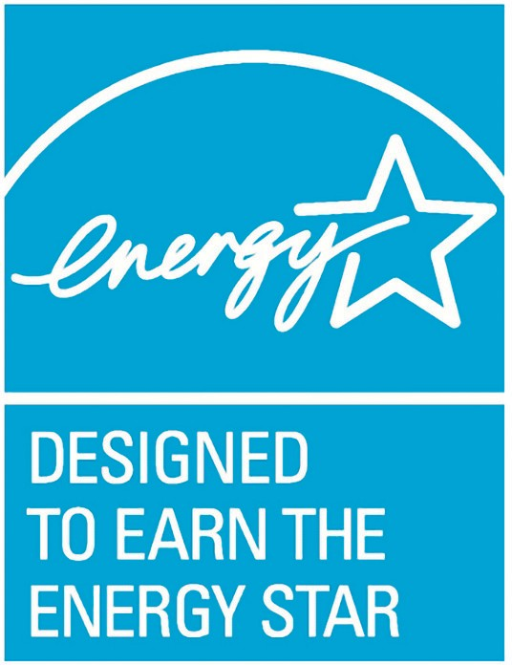B

**Property Name; Property Type [City, State]**

**Owner/Architect of Record**

**Energy Design Metrics**

ENERGY STAR Design Score:

Design Year:

Property Type:

Floor Space [sq ft]:

Percent Energy and   
CO2 Reduction*:

Estimated Energy Use Intensity [kBTU/sf/yr]:

Estimated Total Annual   
Energy Use [kBtu/yr]:

Estimated Annual   
Energy Cost [$$]:

For More Information contact [architect of record or building owner contact information]

*\*Percent Energy and CO2 Reductions are based on comparison to a median building of similar type.*

**Why you choose ENERGY STAR recognition for your design project and used Target Finder & Portfolio Manager tools**  
Reference [***How to Talk and Write about Designed to Earn the ENERGY STAR***](https://www.energystar.gov/buildings/tools-and-resources/how_talk_and_write_about_designed_earn_energy_star).

**Equitable Energy Efficient Design Strategies**  
See the [design profile instructions](https://www.energystar.gov/sites/default/files/tools/2022%20ENERGY%20STAR%20Design%20Profile%20Instructions_508.pdf) and discuss how it applies to:

* Lighting
* HVAC
* Envelope
* Equipment and systems
* Energy savings
* Energy equity (underserved communities)

**Decarbonization and Innovative Design Strategies**

See the [design profile instructions](https://www.energystar.gov/sites/default/files/tools/2022%20ENERGY%20STAR%20Design%20Profile%20Instructions_508.pdf) and discuss how it applies to:

* Renewable energy
* Electrification strategies
* Reducing fossil fuel usage
* Encouraging occupant engagement
* Biophilic design
* Reducing embodied carbon