Help Your Customers Discover Hidden Energy Treasure
Help your customers discover the energy savings hidden in their buildings and facilities. Hundreds of organizations have used energy treasure hunts to reduce their facilities’ energy use by up to 15 percent. With this track record, EPA is launching a Treasure Hunt campaign this October to motivate and recognize organizations that host their own treasure hunts and share a summary of their findings. We need your help to spread the word – and your treasure-finding expertise to help your customers find energy gold.

Why a treasure hunt? Treasure hunts strike a positive, optimistic tone, by focusing on bringing new perspectives to a facility and identifying quick fixes with a short payback period. Once the energy-savings potential is identified, treasure hunts can open the door to deeper, longer-term energy assessments. And building operators and employees who help “discover” treasure are more likely to take ownership of projects, ensuring their completion. The core of an energy treasure hunt is an onsite one- to three-day event in which diverse teams – from onsite facility staff and occupants to outside experts and specialists – look for day-to-day operational improvements.
We’ll make it easy for you to team with EPA to bring this campaign to your customers. EPA provides ready-made co-brandable ENERGY STAR guidance, templates, videos, and recognition – and you bring your customers an opportunity to join a national effort and add your expertise to the table.
Your customers benefit by:
- Cutting energy waste and saving money on utility bills
- Earning EPA recognition for environmental leadership through ENERGY STAR
- Collaborating with team members and boosting workplace pride
- Delivering value to tenants in the form of a more efficient workplace
- Achieving lasting bottom-line benefits
- Saving time and effort with EPA-provided resources
By spreading the word, you benefit by:
- Bringing a proven practice to your customers to save energy
- Catalyzing your customers to help the environment by cutting energy waste
- Attracting new customers and/or identifying opportunities to go deeper with existing customers
- Adding your expertise to the hunt, which can help identify more savings opportunities and pave a path to implementation
- Communicating your role in facilitating the adoption of best practices
- Earning recognition for your involvement as a sponsor

Recognition
EPA is asking organizations to share a summary of their treasure hunt findings online. In return, sponsors and participants will:
- Be featured on www.energystar.gov/treasurehunt
- Receive a printable certificate noting their contributions
- Be included in an EPA communications about the campaign’s results.
Both sponsors and participants will be eligible for recognition from EPA for their efforts.

Eligibility for Participants in the Campaign
- Treasure hunt participants do not have to be ENERGY STAR partners, though partnership is encouraged.
- Non-ENERGY STAR partners must be based in the United States. Sites outside the U.S. can submit results if their parent organization is an ENERGY STAR Partner.
- Organizations can tailor the ENERGY STAR treasure hunt approach to meet a facility’s specific design and needs.
- Third-party sponsors, such as service and product providers (SPPs or energy service companies--ESCOs) and utilities, can submit the results of a treasure hunt on behalf of customers. Both an online form, for single entries, and a data submission template spreadsheet, for multiple entries, will be made available in October to report results.
- Customers, members, or program participants can also indicate that they heard about the campaign from you when they report their savings. This will allow EPA to credit sponsors with helping to promote the campaign.

Restrictions
- The treasure hunt must take place during calendar year 2020.
- Participants must share a summary of their savings online at by January 15, 2021.
- Corporations and organizations with multiple buildings/plants are welcome to participate but must report savings for each site separately. Both an online form and data submission template spreadsheet will be made available to help streamline reporting for single or multiple sites/organizations.
Let us know when you spread the word about EPA’s ENERGY STAR treasure hunts using the ready-to-go materials on the following pages!

Templates and Materials
Web Banners and Buttons 3
Sample Newsletter Article 4
Sample Blast Email 5
Sample Tweets 6
Sample Web Text 7
Additional Copy 8

Web Banners and Buttons
Post one of these web buttons or banners on your website, and link it to www.energystar.gov/treasurehunt. You can also co-brand these graphics with your corporate identifier.
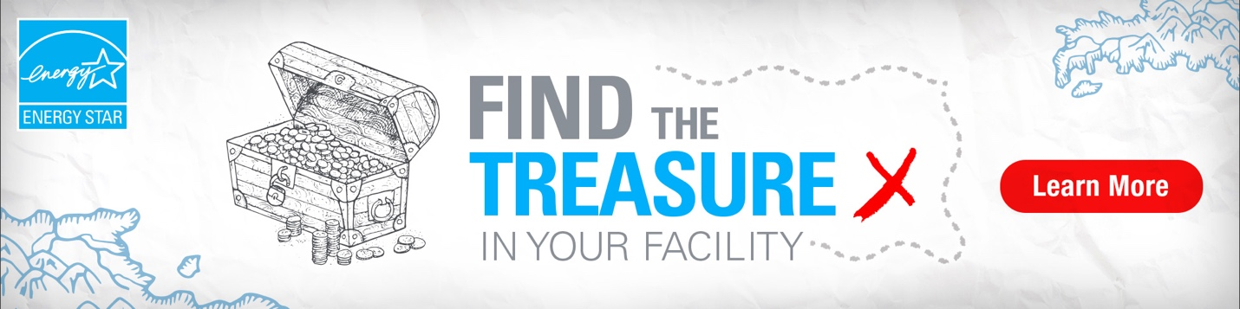
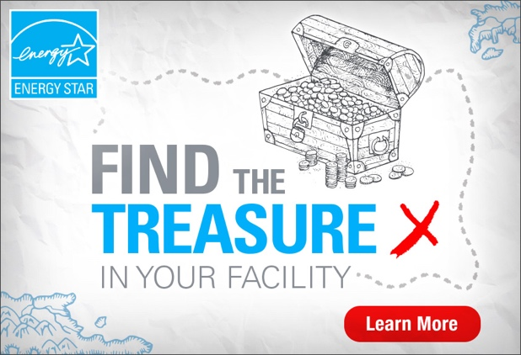
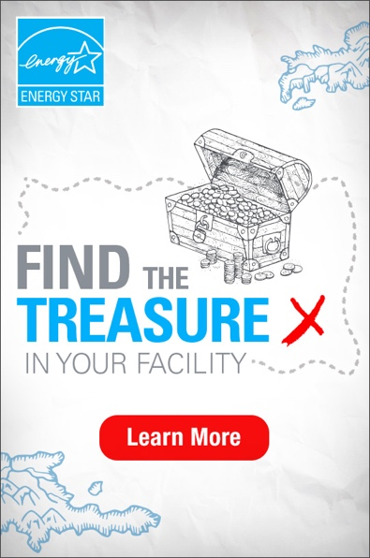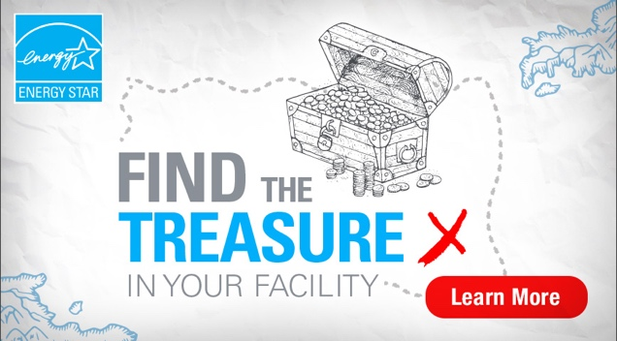

Sample Newsletter Article
EPA and [your (business/organization) name] invite you to discover the hidden energy savings in your building or plant with an ENERGY STAR® treasure hunt!
Join the fun and find savings by teaming up with ENERGY STAR to collaborate alongside us and your facility’s occupants, managers, and team members to build a workplace culture of energy efficiency. We’ll engage one or more of your buildings or facilities today to:
- Cut out energy waste and save money on your utility bills.
- Collaborate with your team members and boost workplace pride.
- Deliver value to your tenants in the form of a more efficient workplace.
- Achieve lasting benefits for your bottom line.
- Save time and effort with EPA-provided resources.
- And be recognized by EPA as an energy-saving leader!
An energy treasure hunt is a one- to three-day event that engages diverse staff and outside energy specialists to bring fresh eyes to a facility and identify low-cost energy savings opportunities from behavioral, operational, and maintenance actions. Hundreds of public and private organizations have used energy treasure hunts to reduce their facilities’ energy use by up to 15 percent. Based on their best practices, EPA has developed step-by-step guidance and treasure “maps” to help others replicate their success.
Based on the guidance and treasure maps available from EPA, we’ll help you collaborate with team members, building owners, and other occupants in tackling energy waste together. Beginning in October, you can or we’ll help you submit your savings online to EPA’s “treasure chest” to see how you have contributed to America’s energy efficiency goals and earn recognition from EPA.
Visit www.energystar.gov/treasurehunt to learn more or contact us to start planning your treasure hunt today.

Sample Blast Email
Start Planning Your Energy Treasure Hunt Today
Energy savings are hidden all around you, if you know where to look. Participate with us in EPA’s ENERGY STAR® Treasure Hunt campaign to find the “energy gold” buried in your facility in a fun, collaborative quest to uncover hidden energy savings, save BTUs, and earn recognition for your efforts.
Using resources available from ENERGY STAR, we’ll help you plan and host a treasure hunt in your facility. And in October, when EPA “opens the treasure chest” and invites organizations to share their findings, we’ll help you submit a summary of your achievements and earn recognition for your accomplishments.
Plus, when you contribute your savings to the treasure chest, you can demonstrate all the possibilities of treasure hunts and inspire others to dig for their own hidden energy treasure.
Visit www.energystar.gov/treasurehunt to learn more about the campaign or contact us to start planning your treasure hunt today.

Sample Tweets
Want to know how your organization can save energy and money? Participate in an @ENERGYSTAR #TreasureHunt to see what #EnergyGold might be hidden in your building! Learn more at energystar.gov/TreasureHunt
Join the quest for #EnergyGold with an @ENERGYSTAR Treasure Hunt. Start saving energy today and learn how you can participate at energystar.gov/TreasureHunt
Who will find the most #EnergyGold this fall? Add savings to the @ENERGYSTAR Treasure Chest at energystar.gov/TreasureHunt

Sample Web Text
Are you looking for ways to save energy, reduce operating costs, collaborate with your facility staff, tenants, or employees, and earn positive publicity for your environmental leadership? Take the first step by hosting an energy treasure hunt with us this fall!
How does it work? Between now and the end of the year, we’ll help you organize and conduct a treasure hunt at your facility. EPA provides themed treasure maps and how-to guides, which we’ll tailor to help you uncover energy savings in your building or facility.
Facilities and companies are encouraged to share a summary the savings uncovered during their treasure hunt via a simple form on the ENERGY STAR website. These reported savings will help fill the collective “treasure chest” with energy gold! And sites that share their findings will be recognized by ENERGY STAR.
How are results measured? To see your energy savings added to the treasure chest, we’ll help you provide EPA with some basic information about your building or facility, as well as:
- Annual energy savings predicted from a hunt
- Annual savings as a percent of energy use
EPA will estimate the total savings across all participants based on identified energy savings and highlight each organization’s contribution to the treasure chest. Both an online form, for single entries, and a data submission template spreadsheet, for multiple entries, are available to share results.
Why should I participate?
- Save energy and money – Organizations conducting treasure hunts typically reduce their facilities’ energy use by up to 15 percent.
- Be a part of the community – Hundreds of organizations have already participated in treasure hunts nationwide. Join in!
- Demonstrate your commitment – Treasure hunts engage a wide range of internal and external stakeholders in uncovering energy savings, which is good for the environment and your bottom line.
- Earn recognition – All facilities and companies that contribute savings will receive a certificate for their participation. Additional recognition will be awarded to facilities and companies that demonstrate outstanding leadership. Both sponsors and participants will be eligible for recognition from EPA for their efforts.
Visit www.energystar.gov/treasurehunt to learn more.

LinkedIn Posts
General Posts:
Conduct an energy treasure hunt and earn recognition from ENERGY STAR by participating in their “Find the Treasure in Your Facility” campaign. Learn more at www.enegystar.gov/treasurehunt
#TreasureHunt #energysavings #energyefficiency #energymanagement #EnergyGold

In 2019, 35 organizations from schools to chemical plants found over $37 million in potential energy cost savings using energy treasure hunts to find low and no cost efficiency opportunities. Learn more how you can find the treasure in your facility at www.energystar.gov/treasurehunt.
#TreasureHunt #energysavings #energyefficiency #energymanagement #EnergyGold

Post for trainings or webinar to your stakeholders that you host:
Looking for ways to save energy, reduce operating costs, collaborate with your facility staff, tenants, or employees – all while earning positive publicity for your environmental leadership? Then join us on Wednesday April 25 at 1 PM for a webinar on Energy Treasure Hunts. To register at: www.yoururl.here/treasurehunt
#TreasureHunt #energysavings #energyefficiency #energymanagement #EnergyGold

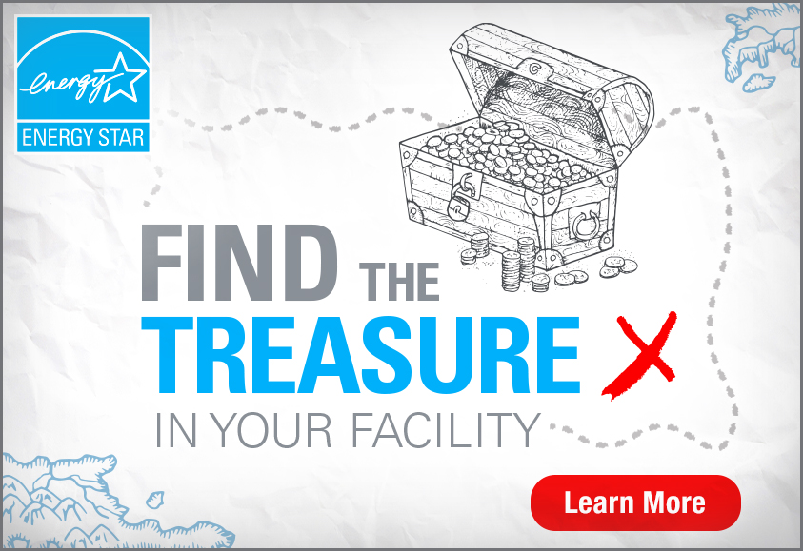

Additional Copy

Start planning your ENERGY STAR treasure hunt today!
Energy savings are hiding all around your building – if you know where to find them! Join the fun and savings as we team up with ENERGY STAR to engage your occupants, building managers, and team members in building a workplace culture of energy conservation. No matter how efficiently your building is designed, your occupants are critical to saving energy and lowering costs. It’s a win for your bottom line and a win for the planet!
Enroll your building today and get ready to:
- Cut out energy waste and save money on your utility bills.
- Earn recognition from the EPA for your environmental leadership.
- Collaborate with your team members and boost workplace pride.
- Deliver value to tenants in the form of a more efficient workplace.
- Achieve lasting benefits for your bottom line.
- Save time and effort with EPA-provided resources!

What’s involved?
We’ll help you plan and implement an energy treasure hunt, based on the guidance provided by EPA for different building and facility types. By helping you identify and organize a diverse team of energy treasure hunters from across the organization, together, we’ll bring a fresh perspective in tackling energy waste and finding hidden energy treasure, one action at a time! Then, we’ll help you submit a summary of your findings to EPA’s “treasure chest” this fall so you can get recognition for your efforts.

Learn More!
Visit www.energystar.gov/treasurehunt to learn more or contact us to get started with planning. Energy gold is just a treasure hunt away!

